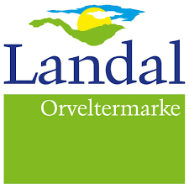
Booking details Dutch Balloon Trophy
Bungalow Type Price
4-person basic * € 602, --
6-person basic * € 646,--
8-person basic * € 899,--
Excluding linen € 13,75 per person and tourist tax € 1,75 per person per night. The above prices are valid until Friday, Feb. 28. Please note that this offer is subject to availability. Full = Full
Date of arrival 28th of May 16.00
Date of departure 2nd of June 10.30
Amount of persons ___________________________
Towels (€11,50) Yes/No * Amount: ……..
Kitchentowels (€10,50) Yes/No * Amount: ……..
Crib (€5,95) Yes/No * Amount: 1/2*
Pet**(€5,50 per pet per night) Yes/No * Amount: 1/2*
Cancellation/travel insurance Yes/No *
(Prices of cancellation insurance and travel insurance depend on the bungalow type. From €30.)
--------------------------------------------------------------------------------------------------------------------------------------
Personal information
Name ___________________________________ Mrs./Ms. Initials ________________
Address ___________________________________________________________________________
Postal code/Residance________________________________________________________________
Phone number _______________________ Mobile: _______________________________________
E-mailaddress_______________________________________________________________________
Date of Birth _____ - _____ - ______
Send the completed form to orveltermarke@landal.com
* Scratch out what does not apply

For questions or any discrepancies, please contact the front desk by emailing orveltermarke@landal.com or calling 0593 - 564100. Information on bungalow types can be found at www.landal.nl/orveltermarke. Please ensure that payment is made on time, by the payment deadlines set by Landal in your confirmation email. If the payment is not made on time, the booking will be automatically cancelled and we will not be able to offer the bungalow for the above prices after February 28.

